CSC387 Lab 09 – IP Services

# Instructions

This lab will focus on some VTP tweaks, synchronizing device time with NTP, pushing logs to syslog, and making your devices readable by SNMP.

The following should be completed on Packet Tracer. Please take a screen shot of each of the Verification Steps (below) and submit in a labeled single word document using the screenshot guide in the class content on D2L. Make sure your device names are visible in the screen shot! Don’t forget to save your Packet Tracer file.

### Network Diagram

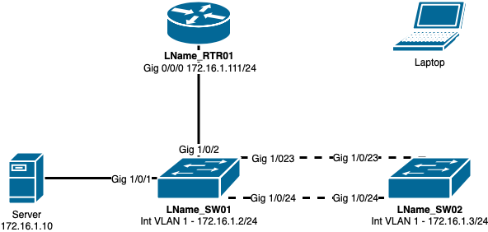

The switches can be Cisco 3650-24PS and the router will be a Cisco 4331.

### Configuration Tasks

Cable the network as shown in the above network diagram.

1. Set up all devices to have the appropriate hostnames (switches and router).
2. Turn off IP domain-lookups on the router and switches.
3. Since we’re working with logging, set the console ports of the router and the switches to have synchronous logging. That way the messages coming up won’t interrupt your typing.
4. Configure the interface and VLAN IPs as shown in the diagram.

SW01

1. Create the following VLANs with the corresponding port assignments:

|  |  |  |
| --- | --- | --- |
| **VLAN Name** | **VLAN ID** | **VLAN Ports** |
| DEFAULT (already exists) | 1 | 1-12 |
| USERS | 2 | 13-22 |

1. Configure ports 23, and 24 as trunk ports. All other ports on both of the switches can be made into access ports.

SW02

This switch should have the following configurations performed:

1. Configure ports 23 and 24 as trunk ports. All other ports on both of the switches can be made into **access** ports.
2. Assign the following ports to the corresponding VLANs. You can use VTP (recommended) or manually create the VLANs this time.

|  |  |  |
| --- | --- | --- |
| **VLAN Name** | **VLAN ID** | **VLAN Ports** |
| DEFAULT (already exists) | 1 | 1-4 |
| USERS | 2 | 5-22 |

### Spanning Tree

There’s not a ton of config to do with STP, but we can make some tweaks in our network.

1. Set both switches to use Rapid-PVST.
2. Force SW01 to become the root bridge for VLAN1 and SW02 to be the root bridge for VLAN 2. You can do this by setting the priority values or setting them to be root primary.
3. Configure all access ports on both switches to use portfast and bpduguard.

Verification Step 1

## LLDP

We’re looking at having a multi-vendor setup in our environment. Let’s start switching off of proprietary protocols.

1. Configure RTR01, SW01, and SW02 to use LLDP.
2. Since we’re not using CDP anymore, turn it off.

Verification Step 2

## NTP

Before starting with centralized logging, you need to have accurate and precise time throughout your network.

1. Connect your laptop to SW02 in any of the VLAN 1 ports and give it an appropriate IP address.
2. Browse to the server at [http://172.16.1.10](http://172.16.1.10/) and ensure you can reach the webpage.
3. Configure your router to use milliseconds for its service logging timestamps.
4. Configure NTP on the server.
   1. Set the date and time to be as current as possible.
   2. Enable authentication
   3. Key **1** should have the password of **csc387**.
5. Set your router’s time zone to be **CST -6**.
6. In order for your time to sync to NTP, it must be reasonably close to the NTP clock. Update your router’s time to be close to the server using the **clock set** command. Within a couple of minutes should be fine.
7. Verify your router’s time is close by running **show clock**. If your router’s clock is not close to the NTP server’s time, do not proceed until you set it correctly.
8. The NTP server is authenticated. Configure your router to connect to the NTP server via

**172.16.1.10.**

* 1. Create **authentication-key 1** to have the **md5** password of **csc387**
  2. Make key **1** a trusted key.
  3. Set the NTP server to be **172.16.1.10** using key **1**.

Verification Step 3

### Syslog

After you have successfully synced your router’s clock to the NTP server, you can start pushing log files to syslog.

1. Configure your router’s logging to go to the host **172.16.1.10**
2. Set the logging trap to **debugging**.
3. Turn on **ip icmp** debugging.
4. Ping **172.16.1.10** and you should get successful replies as well as the debug messages.

Verification Step 4

## SNMP

After you’ve successfully confirmed that your router is pushing its log files to the syslog server, you need to read SNMP information from it.

1. Configure your router with the SNMP community string of **dsu** and set the permissions to **read write (rw)**.

Verification Step 5

### Verification Steps

1. 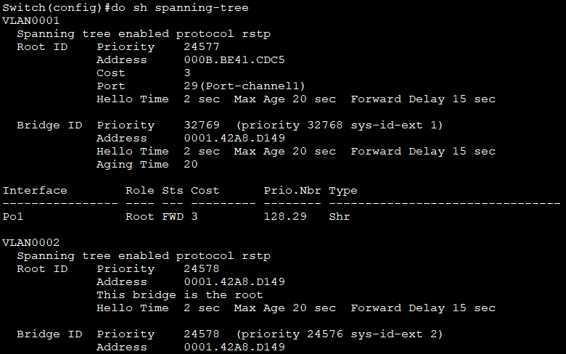On either of the switches, do a **show spanning-tree**. You should see one switch is the root bridge for VLAN 1, the other switch is the root bridge for VLAN 2.
2. 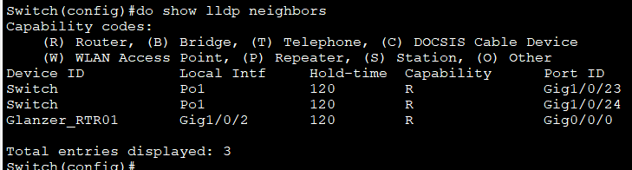On SW01, run a **show lldp neighbors** from privileged exec. You should see your connections to RTR01 and SW02.
3. 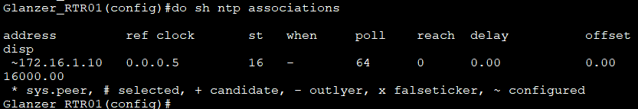Run **show ntp associations** from your router’s privileged exec mode. You should see that the server 172.16.1.10 server is synced (it will have a * by it). Next, run **show ntp status** and you’ll see that the clock is synchronized.
4. 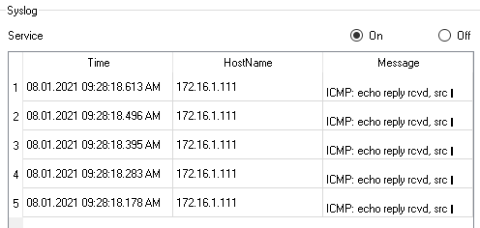Open up the **SYSLOG** console of the server. You should be able to see syslog entries displayed on the webpage from your pings. The syslog entry will have the log time as well as your router’s IP as the source of the message.
5. After you’ve enabled the SNMP community string on your router, go to the laptop and open up the **MIB Browser**.
   1. Get the .**sysName** and **.sysDescr** objects**.** Take a screenshot of both.
   2. 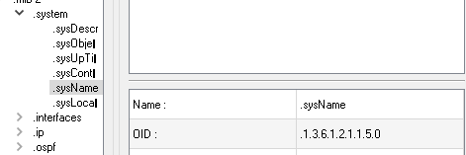

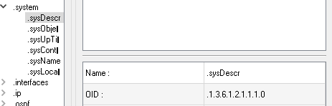

# What to Turn In

Go through each of the verification steps and take a screenshot. Please try to show each step in a single, clear screenshot to cut down the number of images. Also, paste all screenshots into a single Word/PDF document. Do not upload them to D2L as individual images – I won’t grade them.